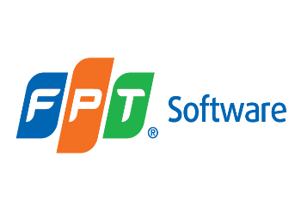

***Entity Framework***

**Lab Guides**

|  |  |
| --- | --- |
| Document Code | 25e-BM/HR/HDCV/FSOFT |
| Version | 1.1 |
| Effective Date | 20/11/2012 |

**Hanoi, 07/2019**

RECORD OF CHANGES

|  |  |  |  |  |  |
| --- | --- | --- | --- | --- | --- |
| No | Effective Date | Change Description | Reason | Reviewer | Approver |
|  | 01/Oct/2018 | TuTB create new | Draft |  |  |
|  |  |  |  |  |  |
|  |  |  |  |  |  |
|  |  |  |  |  |  |
|  |  |  |  |  |  |
|  |  |  |  |  |  |
|  |  |  |  |  |  |
|  |  |  |  |  |  |
|  |  |  |  |  |  |
|  |  |  |  |  |  |

Contents

Lab: Creating an Entity Data Model 4

Objectives: 4

Prerequisites: 4

Problem Description: 4

Guidelines: 4

Step 1: Open Visual Studio and create a console project 4

Step 2: Check .net Framework version 4

Step 3: Add Entity Data Model 4

Step 4: Select the **EF Designer from database** option 6

Step 5: Create a connection with your existing database 7

Step 6: Choose the version of Entity Framework 7

Step 7: Select the Tables, Views and Stored Procedures 8

Step 8: Import selected stored procedures and functions into entity model 8

|  |  |
| --- | --- |
|  | **CODE: NEFW.S.L002**  **TYPE: SHORT**  **LOC: 100**  **DURATION: 30 MINUTES** |

# Lab: Creating an Entity Data Model

Objectives:

* Create an Entity Data Model (EDM) for an existing database in database-first approach.

Prerequisites:

* Download and installs Visual Studio (included .net Framework).

Problem Description:

* Write a C# console application to show Hello World message.
* Use the Console.WriteLine statement to print the message to console.

Guidelines:

### Step 1: Open Visual Studio and create a console project

### Step 2: Check .net Framework version

Go to Project in the menu -> {project name} Properties.. - and make sure that the project's target framework is .NET Framework 4.5, as shown below.

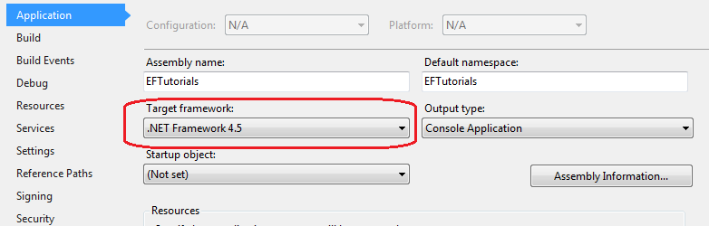

### Step 3: Add Entity Data Model

Right clicking on the project in the solution explorer -> Add -> New Item.

This will open the Add New Item popup.

In the popup, select ADO.NET Entity Data Model and provide an appropriate name to the EDM ('School' in this case) and click the Add button.

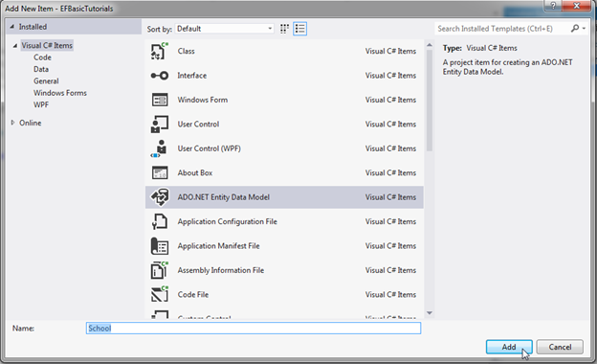

### Step 4: Select the **EF Designer from database** option

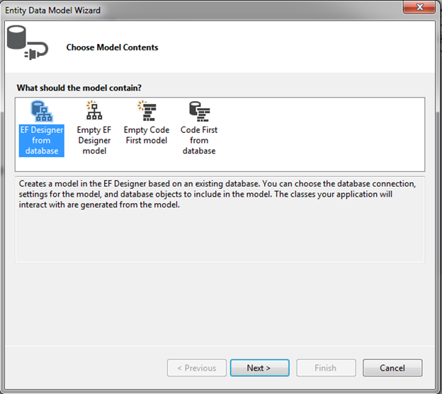

### Step 5: Create a connection with your existing database

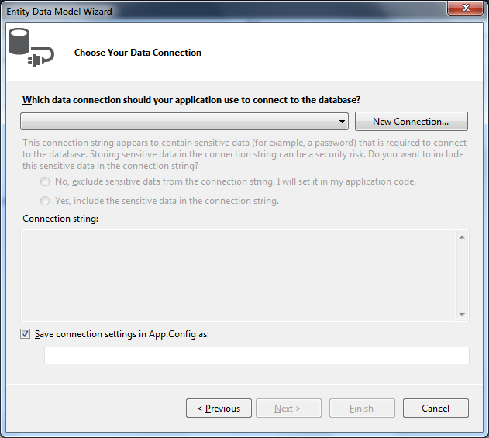

### Step 6: Choose the version of Entity Framework

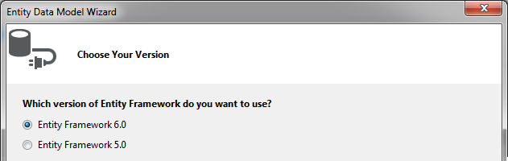

### Step 7: Select the Tables, Views and Stored Procedures

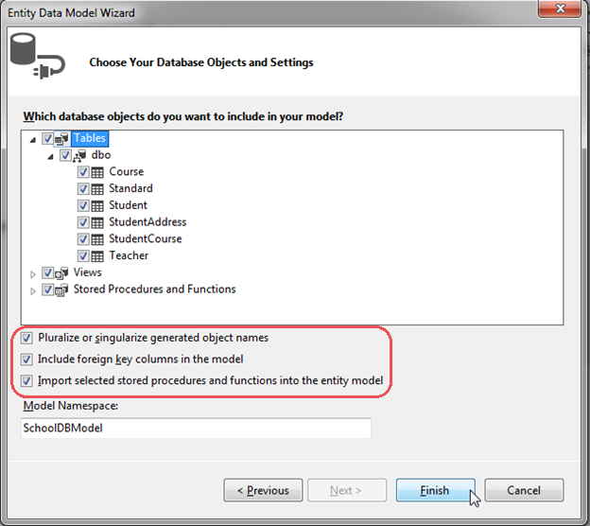

### Step 8: Import selected stored procedures and functions into entity model

